MATLAB-7(EXPERIMENT)

NAME- AKALPYA KHARE
SECTION- CSE02
ROLL NUMBER-24051757

AIM To apply Euler’s numerical method for solving a first-order ordinary differential equation (ODE) with a given initial condition, and to approximate the solution at discrete points using MATLAB.
OBJECTIVE
- Define the ODE: dy/dx=1+x^2
- with the initial condition y(1)=-4.
- Implement Euler’s Method:
Use the iterative formula.y{i+1}=y{i}+h. f(xi ,yi)
- where h is the step size.
- Perform Numerical Computation:
- Start from x_0=1,y_0=-4.
- Use step size h=0.01.
- Compute approximate values of y at x=1.01,1.02,1.03.
- Display Results:
Print the computed values of x and y for each iteration.
Problem Statement
We are required to solve the initial value problem (IVP):
dy/dx=1+x^2, y(1)= -4
Using Euler’s method with step size h=0.01. The task is to compute approximate values of y at x=1.01,1.02,1.03, and analyze the accuracy of the numerical solution compared to the exact analytical solution.
INPUT:

clc;
close all;
clear all;

f = @(x,y) 1 + x^2;
x0 = 1;
y0 = -4;
xg = 1.03;
h = 0.01;
n = (xg - x0)/h;

x = x0;
y = y0;

for i = 1:n
y = y + h*f(x,y);
x = x + h;
fprintf('x=%0.4f y=%0.6f\n', x, y);
end

OUTPUT:
x=1.0100 y=-3.980000
x=1.0200 y=-3.959799
x=1.0300 y=-3.939395

Problem Statement
We are required to solve the initial value problem (IVP):
dy/dx=x+y, y(0)=1
over the interval [0,1] using Euler’s numerical method with a step size of h=0.2. The task is to compute approximate values of y at x=0.2,0.4,0.6,0.8,1.0, and to visualize the numerical solution using MATLAB with a respective graph of it.

INPUT:

clc;
close all;
clear all;

f = @(x,y) x + y;
x0 = 0;
y0 = 1;
xg = 1;
h = 0.2;
n = (xg - x0)/h;

x(1) = x0;
y(1) = y0;

for i = 1:n
y(i+1) = y(i) + h * f(x(i), y(i));
x(i+1) = x(i) + h;
fprintf('x=%0.4f y=%0.6f\n', x(i+1), y(i+1));
end

plot(x, y, '-o','LineWidth',1.5,'MarkerSize',6);
xlabel('x');
ylabel('y');
title('Euler solution');
grid on;

OUTPUT:

x=0.2000 y=1.200000
x=0.4000 y=1.480000
x=0.6000 y=1.856000
x=0.8000 y=2.347200
x=1.0000 y=2.976640

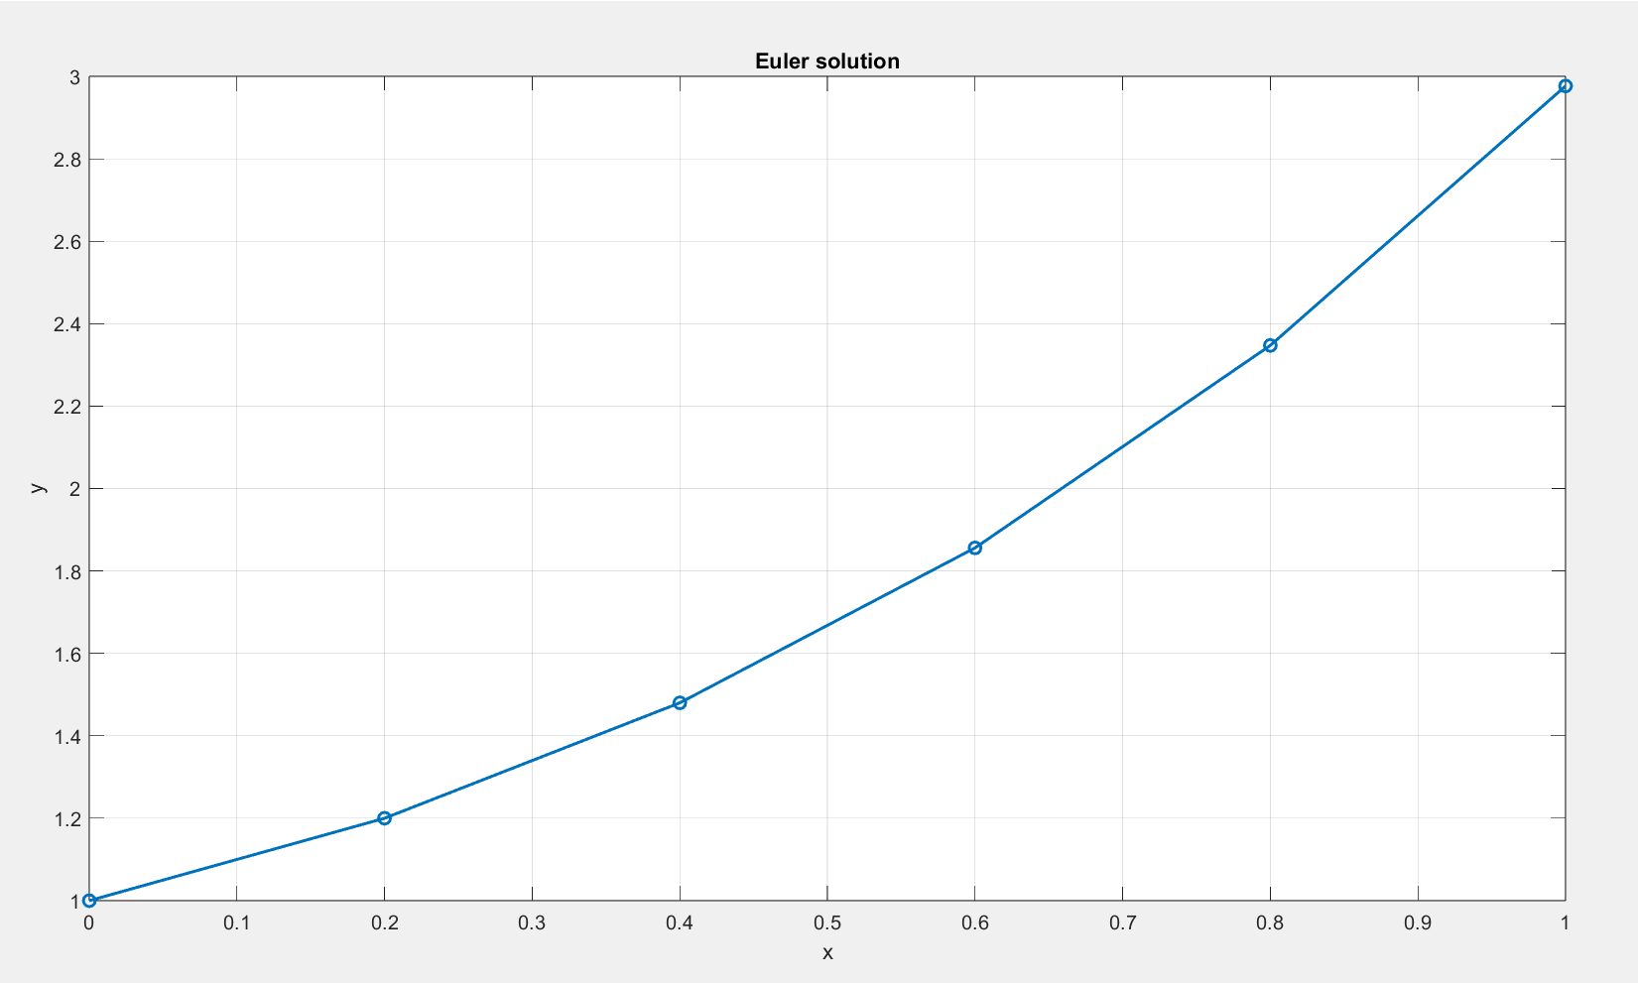

CONCLUSION
Euler’s method, applied to both problems, demonstrates its simplicity and effectiveness for approximating solutions of first-order ODEs.
- In the first case (dy/dx=1+x^2), with a small step size, the method produced results very close to the exact solution, showing high accuracy.
- In the second case (dy/dx=x+y), with a larger step size, the method followed the correct growth trend but underestimated the exact solution, and the error increased with each step.
Overall, Euler’s method is easy to implement and works well for short intervals and small steps, but accuracy decreases with larger steps or rapidly growing functions.

